Ye,Zhengkun

Java project 5

03/27/14

**package** com.project5;

**import** java.util.Scanner;

**public** **class** ScanningText {

**public** **static** **void** main(String args[])

{

String line, temp;

System.*out*.println("Enter a single line of text ");

Scanner sc = **new** Scanner(System.*in*);

line = sc.nextLine();

line = line.toLowerCase(); //convert to lowercase

line = line.replaceAll("[\\s\\p{Zs}]+", " "); //make multi space to a whitespace

line = line.trim(); //omit the whitespace at head and tail

**int** ch, count, singleCharCnt=0;

**int** ic,MAX = 0;

**int** frequency[] = **new** **int**[26];

**for** (ch='a'; ch <= 'z'; ch++){

count = 0;

**int** index = ch - 97;

frequency[index] = 0;

**for** (ic = 0; ic < line.length(); ic++){

**if**(line.charAt(ic) == ch) //count the specific char (a-z)

count++;

}

frequency[index] = count;

singleCharCnt += count;

}

String []emitspace = line.split(" "); //divide string into words by whitespace

**for**(String item:emitspace){

**if**(item.length()> MAX)

MAX = item.length();

}

/**************************** Output ********************************/

System.*out*.println("\nThe line contains " + singleCharCnt + " letters");

System.*out*.println("The line contains " + emitspace.length + " string tokens");

System.*out*.println("The longest token has " + MAX + " letters");

System.*out*.println("The frequency of letters is " );

**for**(ic = 'a'; ic < 'z'; ic++){

**if**(frequency[ic-97] > 0){

**char** c = (**char**)(ic-32);

System.*out*.print(c + " -- " + frequency[ic-97]+"\n");

}

}

}

}

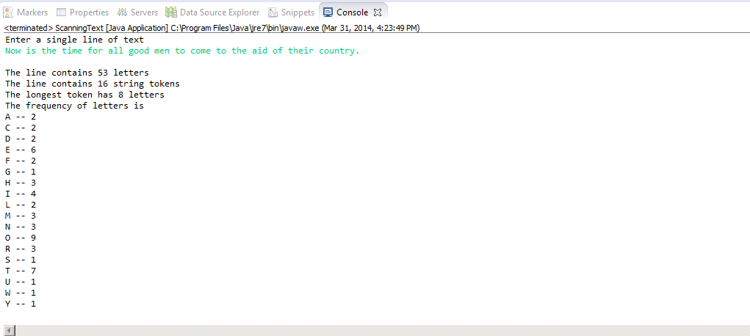

**import** java.util.Scanner;

**public** **class** BinaryConversion {

**public** **static** **void** main(String []args){

String input;

**while**(**true**){

System.*out*.println("Enter a binary number");

Scanner sc = **new** Scanner(System.*in*);

input = sc.nextLine();

**if**(input.equals("-1")){

System.*out*.println("All set!");

**break**;

}

**else** {

**int** result = *binaryToDecimal*(input);

System.*out*.println("Conversion to decimal: " + result);

}

}

}

**public** **static** **int** binaryToDecimal (String binaryString){

**int** size = binaryString.length();

**int** i, temp = size;

**int** result = 0;

**for**(i = 0; i < size; i++){

temp = temp - 1;

**if**(binaryString.charAt(i) == '1'){

result += *mypow*(2, temp);

}

}

**return** result;

}

**public** **static** **int** mypow(**int** d, **int** m){

**int** result = 1;

**int** temp = m;

**while**(temp != 0){

result = result * d;

temp--;

}

**return** result;

}

}

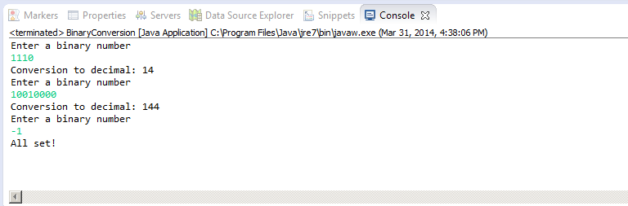

package com.project5;

import java.text.DecimalFormat;

import java.util.ArrayList;

import java.util.Scanner;

//Are we allowed to use the ArrayList for a array with dynamic length?

public class Reverse {

public static void main(String []args){

int[] positive = new int[100];

System.out.println("Please enter the integers:");

Scanner input = new Scanner(System.in);

int temp, size=0;

temp = input.nextInt();

while(temp != -1){

positive[size] = temp;

size++;

temp = input.nextInt();

}

int[] tempArray = new int[size];

for(int i=0; i<size; i++){

tempArray[i] = positive[i];

}

reverse(tempArray);

int total = 0;

System.out.println("The values in reverse order are");

for(int i=0; i<size; i++){

System.out.print("\t" + tempArray[i]);

total += tempArray[i];

}

System.out.print("\nThe average is " + total + "/" + size + "=" );

double divide = (double)total/size;

DecimalFormat df = new DecimalFormat("#.0");

System.out.println(df.format(divide));

}

public static void reverse(int[] A){

int len = A.length-1;

int half = len/2;

for(int i=0; i <= half; i++){

int temp = A[i];

A[i] = A[len-i];

A[len-i] = temp;

}

}

}

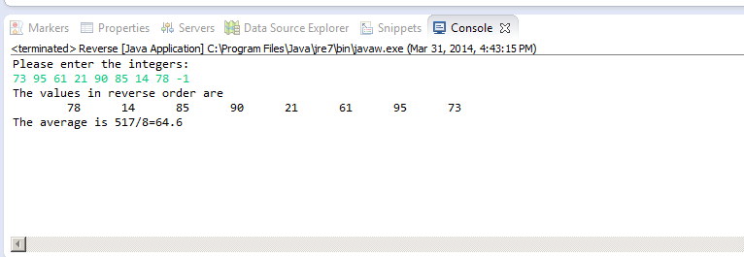

**package** com.project5;

**import** java.util.Scanner;

**public** **class** ValidPhoneNumbers {

**public** **static** **void** main(String[] args){

System.*out*.println("Please enter the phone numbers");

Scanner sc = **new** Scanner(System.*in*);

String input = sc.nextLine();

**boolean** flag = *isValid*(input);

**if**(flag){

System.*out*.println("Yes, it's valid");

}

**else**{

System.*out*.println("No, it's invalid");

}

}

**public** **static** **boolean** isValid(String inputString){

**int** fixedLen = 12;

String newString = inputString.trim();

**if**(newString.length()!= fixedLen){

**return** **false**;

}

**else** {

**for**(**int** i=0; i < fixedLen; i++){

**char** ch = newString.charAt(i);

**if**(ch != '-' && (ch < '0' || ch > '9')){

**return** **false**;

}

**else** **if**(ch == '-' && (i != 3 && i != 7)){

**return** **false**;

}

}

}

**return** **true**;

}

}

